**Quick Parent & Student Guide**

**School Website link:** [https://www.bridgeprep](https://www.bridgeprepgreatermiami.com/)palmbeach

**New Student Accounts**

1. A new student must visit your school website and create their account using the **Create Account** form.

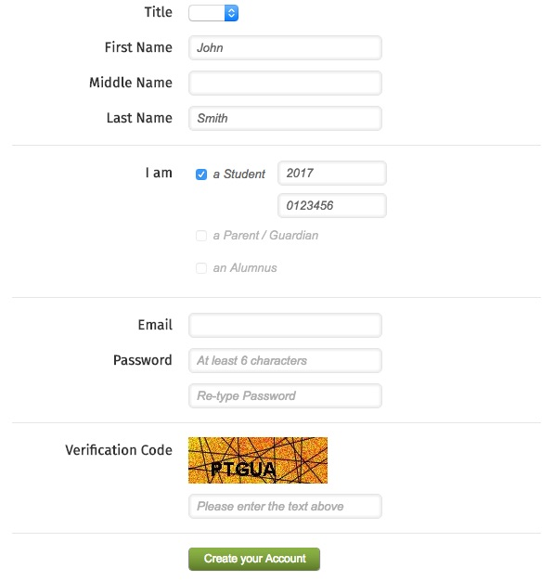

1. After completing the new account form, a student will receive an email to verify their email address and activate their account. They must click the **Activate Account** button in the email they receive.

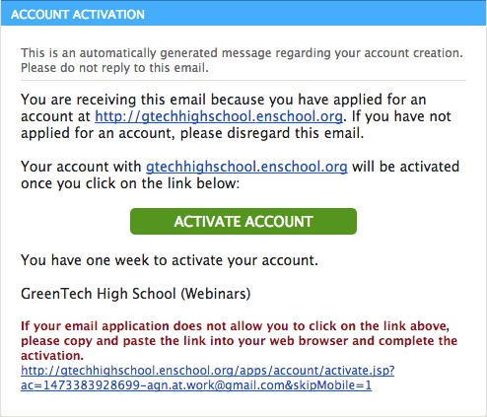

1. After activating their account, they will receive an email with a **verification code**

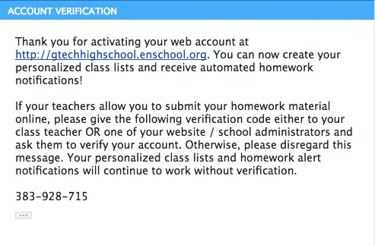

1. The student must then physically give their verification code to one of their teachers.
2. The teacher must then click on **My Students and Parents** from their admin area, and then click on the **Verify Student Accounts** button.

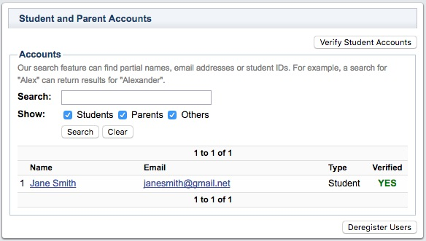

1. The teacher will then enter the verification code provided by the student.

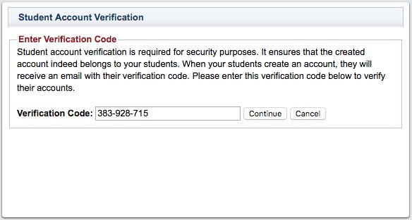

1. After reviewing the student's information, click on the **Approve** button to complete the student verification process.

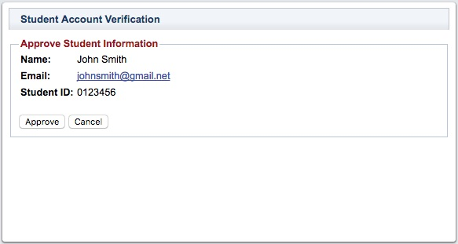

If your website doesn't have a Login / Create Account option, please contact Technical Support using the help desk and request for it to be added somewhere on your. [show me](javascript:;)